## Tester: Phạm Tuấn Kiệt, Trịnh Huỳnh Đức

Date: 11/4/21

## User: Marketing Manager

Goal: Marketing Manager can view the dashboard and reports of all the articles in all of the faculties. He/She can also download all the articles after the closure date into a .zip file

Triggers: User login using the Marketing Manager account

Preconditions: Marketing Manager account must exist in the database and accessible.

## Test case:

Login

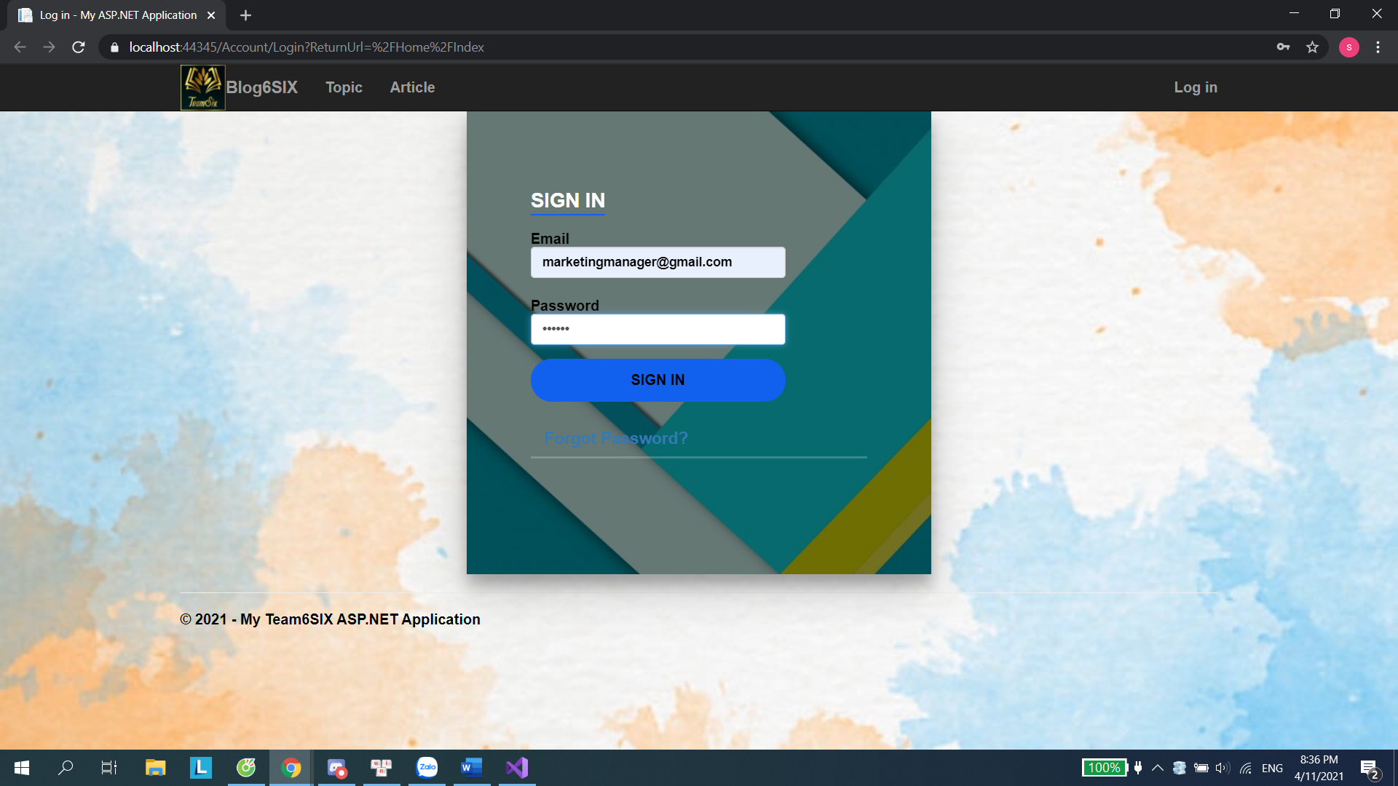

HomePage

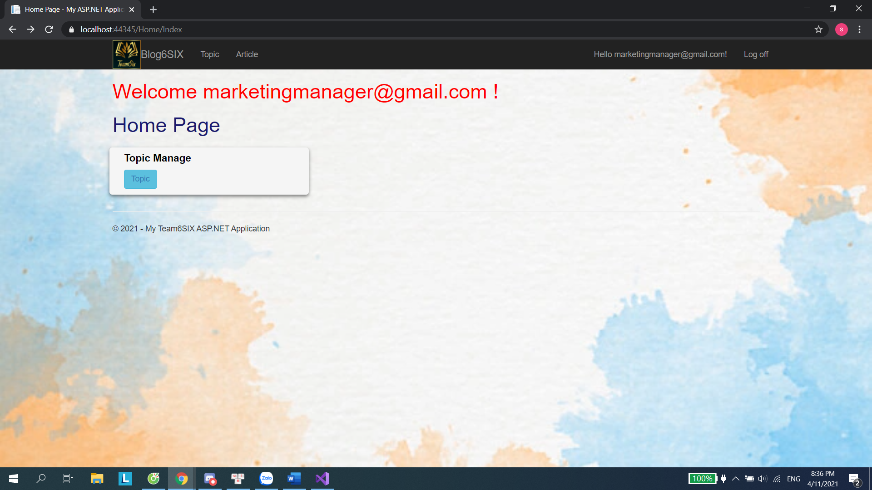

Topic Manage Page

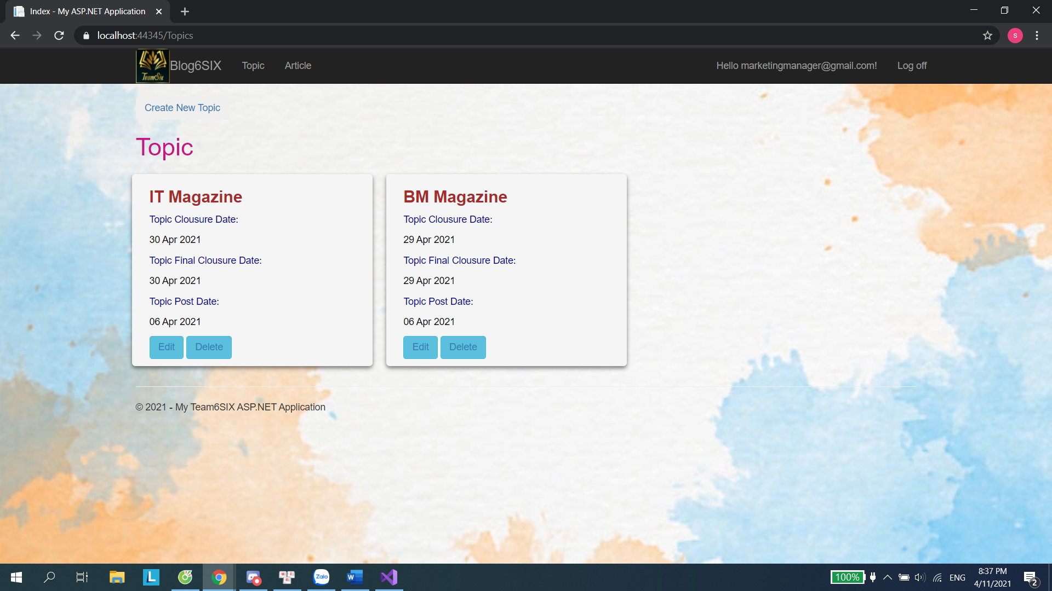

Create new Topic

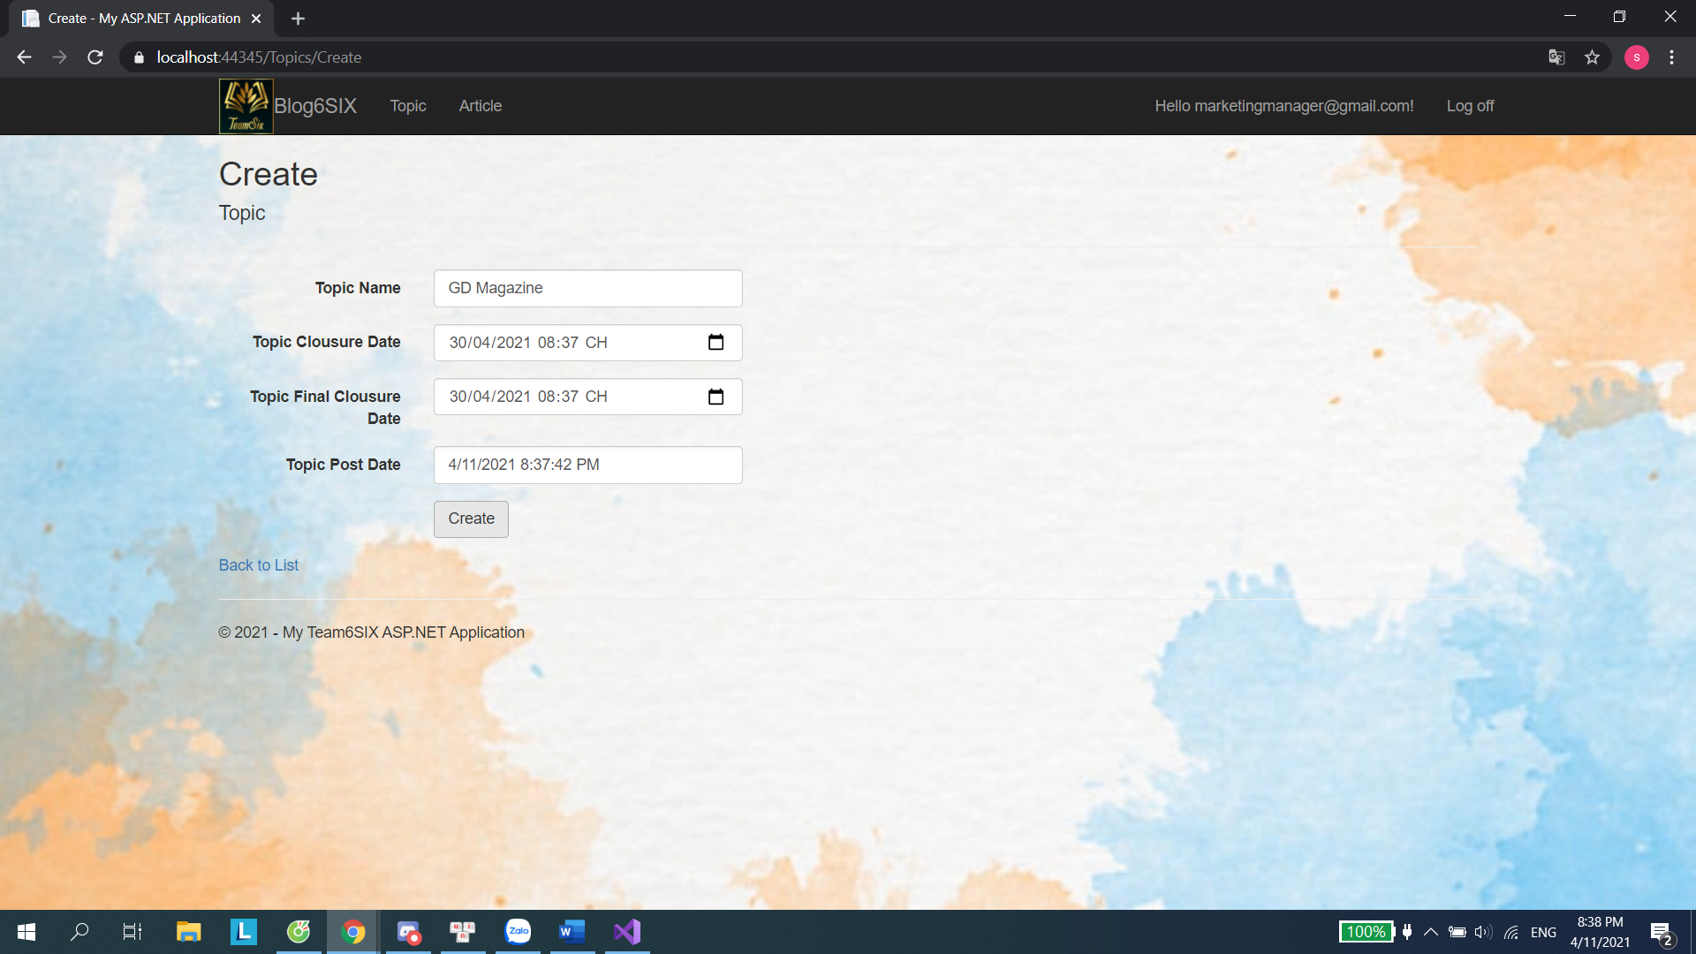

Create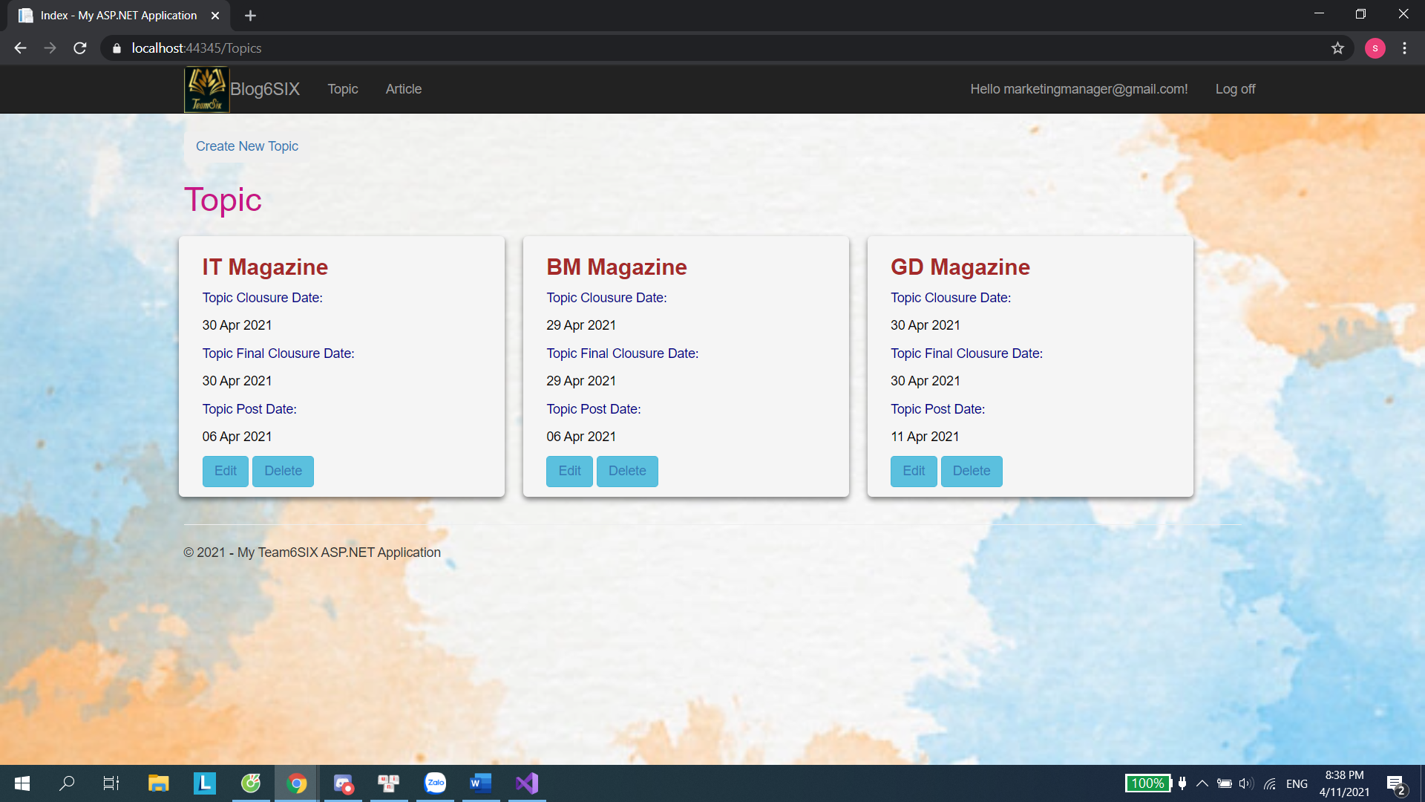

Delete new topic

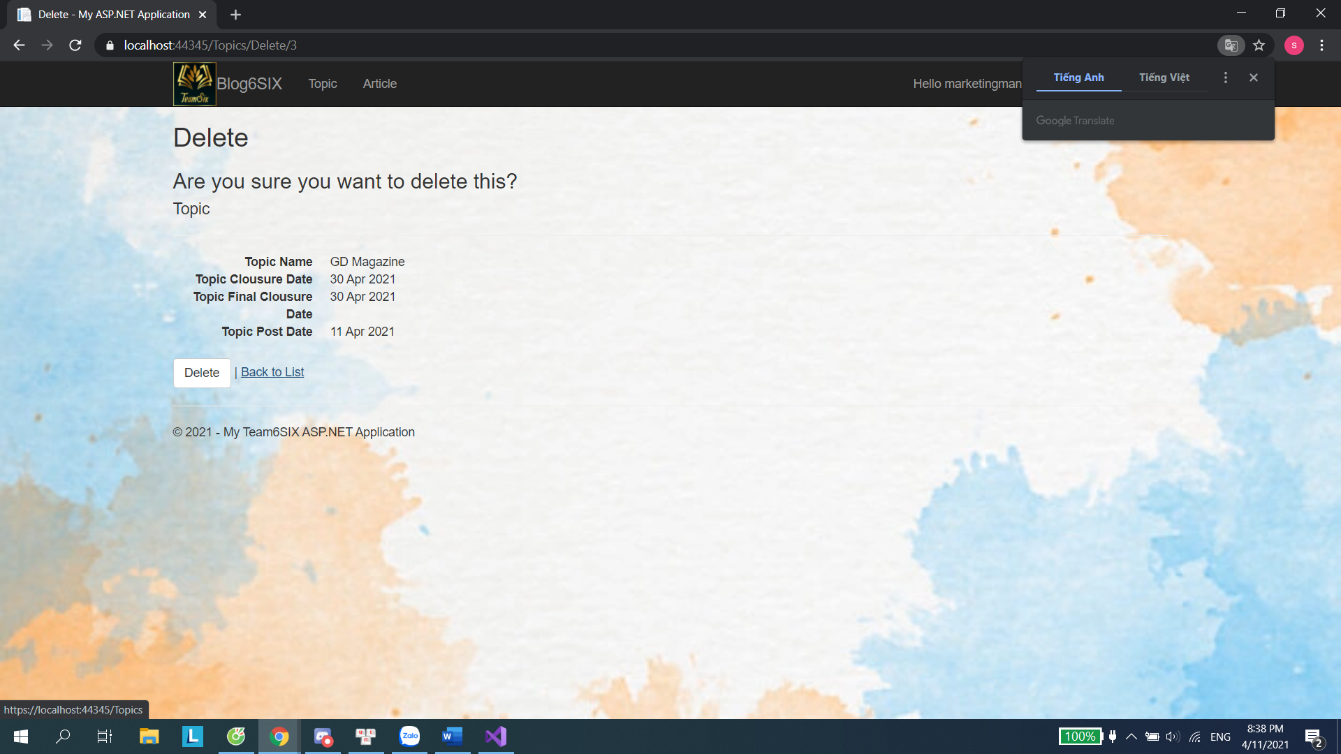

View All Article

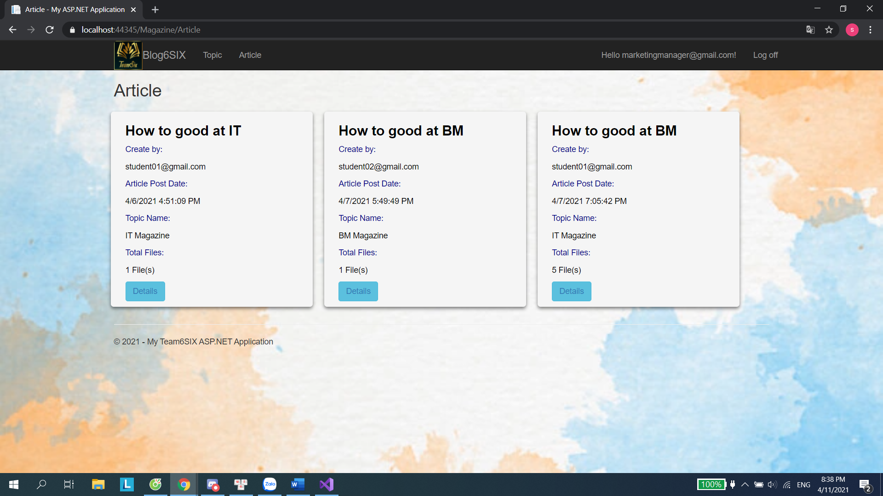

Download but not have Zip File

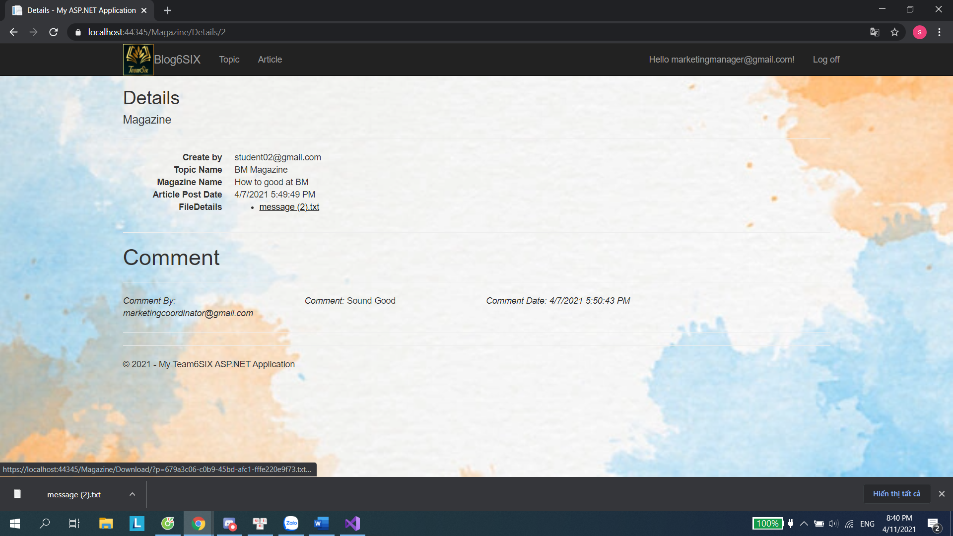

|  |  |  |  |  |  |
| --- | --- | --- | --- | --- | --- |
| **Functions** | **Test Scenario** | **Step Description** | **Expected Result** | **Actual Result** | **Status** |
| Test if Marketing Manager can logon | MM can logon into the system using their accounts | 1) Enter the Login page 2) Input MM’s username and password | MM should be login into the system and redirected back to the Home page | Successful | Pass |
| Test if Marketing Manager can see the Dashboards | MM can see the Dashboards about the articles in the Home Page | 1) Login using a MM account 2) View the Home page | The Dashboards should be displayed | Nothing | Fail |
| Test if Marketing Manager can see the Reports | MM can see the Reports about the articles in the Reports Page | 1) Login using a MM account 2) View the report page | The Reports should be displayed | Successful | Pass |
| Test if Marketing Manager can download the articles into a .zip file | MM can download all articles into a .zip file | 1) Login using a MM account 2) Click on the download button | The ZIP file should be downloaded successfully with all the articles inside | Nothing | Fail |